LINSTITUTE OF RURAL DEVELOPMENT PLANNING- DODOMA

DEPARTMENT OF ENVIRONMENTAL PLANNING
IMPLICATIONS OF DALADALA CUT OFF TRIPS ON PASSENGERS TRAVELLING EXPERIENCE: A CASE OF MACHINGA COMPLEX TO ST GEMMA ROUTE IN DODOMA CITY BY

CATHERINE A KIMBE
A DISSERTATION SUBMITTED IN PARTIAL FULFILLMENT FOR THE REQUIREMENTS OF THE AWARD OF BACHELOR IN URBAN DEVELOPMENTAND ENVIRONMENTAL MANAGEMENT OF THE INSTITUTE OF RURAL DEVELOPMENT PLANNING, DODOMA, TANZANIA

SEPTERMBER, 2024

ABSTRACT
This study was conducted in Dodoma City, Tanzania, focusing on the implications of daladala cut-off trips on passengers traveling from Machinga Complex to St. Gemma. The overall objective was to assess the impact of these interruptions on passenger experiences. Specific objectives included examining the route patterns, identifying factors causing cut-off trips, and determining the challenges faced by passengers. Data collection involved surveys, interviews, and focus group discussions with passengers and daladala operators, with a sample size of 70 passengers and 10 operators. Analysis was conducted using descriptive statistics through SPSS. Key findings revealed that daladala cut-off trips led to increased travel costs, longer travel times, and passenger dissatisfaction. The main factors contributing to these disruptions were economic pressures on drivers, regulatory challenges, and infrastructural issues like traffic congestion. Passengers reported significant inconveniences, including unpredictability and safety concerns, particularly impacting women and students. The study concluded that daladala cut-off trips negatively affect the reliability of public transport, hindering economic and educational activities. Recommendations include enhancing regulatory oversight, improving infrastructure, and developing policies to support the growth and efficiency of the daladala system. These measures aim to provide reliable and affordable public transport, improving the overall travel experience for Dodoma City residents.

DECLARATION
I Catherine A. Kimbe, declare that this dissertation is my own original work and that it has not been presented to any other Institute for a similar or any other degree award
Signature…………………………………………………..
Date………………………………………………………...

COPYRIGHT
No part of this paper may be produced or transmitted in any form and by any means without permission of the writer or the Institute of Rural Development Planning.

RESEARCH SUPERVISOR’S CERTIFICATION
I Ms. Reshian Kanyatila certify that I have read and hereby recommend for acceptance by the Institute of Rural Development Planning the dissertation entitled implications of daladala cut off trips on passengers travelling experience in fulfilment of the requirements for the degree in urban development and environmental Management of the Institute of Rural Development Planning.
Signature………………………………………………
Date……………………………………………………

ACKNOWLEDGEMENTS
I thank God for his grace and mercy during the whole period of my studies at Institute of rural development planning and for the whole of my life. I have seen his protection, guidance.
Ms. Reshian Kanyatila my dissertation supervisor and my mentor, I would like to extend my sincerely appreciation to you. Thank you for your dedicated assistance, criticism, comments, and wealthy professional experience you shared to me that profoundly made this study possible.
Special thanks should go to all my contacts, interviewees and informants who provided key information used in the study. Thank you, Project official’s officials, as well as Ward extension officer for your kind support in providing required information that helped me to come up with this work.
I extend my earnest gratitude to all lecturers and Department of environmental planning for their care and professional mentorship during my study. Besides, thank you all my beloved friends at the Institute of Rural Development Planning Dodoma from urban development and environmental planning class of 2024 for your comments and contribution especially during colloquium. We have been studying and living together under one belief that sharing is caring.
Thank you, Mom and Dad, for bringing me up and offering me the precious opportunity to study at IRDP. To all and sundry who have prayed for me, assisted and contributed in diverse ways to this level, May God bless you all.

TABLE OF CONTENTS
ABSTRACT i
DECLARATION ii
COPYRIGHT iii
RESEARCH SUPERVISOR’S CERTIFICATION iv
ACKNOWLEDGEMENTS v
TABLE OF CONTENTS vi
LIST OF TABLES x
LIST OF FIGURES xi
LIST OF PLATES xii
LIST OF APPENDICES xiii
LIST OF ABBREVIATIONS AND ACRONYMS xiv
DEFINITIONS OF KEY TERMS AND VARIABLES xv
CHAPTER ONE 1
INTRODUCTION 1
1.1 Background of the Study 1
1.2 Problem Statement 5
1.3 Significance of the Study 6
1.4 Research Objectives 6
1.4.1 General Objective 6
1.4.2 Specific Objectives 6
1.5 Research Questions 7
1.6 Scope of the study 7
CHAPTER TWO 9
LITERATURE REVIEW 9
2.1 Theoretical Review 9
2.1.1 Paratransit Theory 9
2.1.2 Travel Demand Management (TDM) Theory 9
2.1.3 Theory of Constraints 10
2.2 Empirical Review 11
2.2.1 Route pattern of Machinga Complex to St Gemma daladala 11
2.2.2 Factors behind daladala cut off trips from Machinga Complex to St Gemma 12
2.2.3 Challenges facing passengers as a result of daladala cut off trips 13
2.3 Information Gap 13
2.4 Conceptual Framework 15
CHAPTER THREE 16
RESEARCH METHODOLOGY 16
3.1 Study Area 16
3.2 Research Design 18
3.3 Data Types and Sources 18
3.3.1 Primary Data 18
3.3.2 Secondary Data 18
3.4 Data Collection Methods and Tools 19
3.5 Sampling 20
3.5.1 Sampling Frame 20
3.5.2 Sampling Unit 20
3.5.3 Sampling Size 20
3.5.4 Sampling Procedures 20
3.7 Data Processing, Analysis and Presentation 21
3.7.1 Data Processing 21
3.7.2 Data Analysis 21
3.7.3 Data Presentation 21
CHAPTER FOUR 22
RESULTS AND DISCUSSION 22
4.1 Introduction 22
4.2 Characteristics of respondents 23
4.2.1 Gender distribution 24
4.2.2 Age distribution 24
4.2.3 Marital status 24
4.2.4 Education level 25
4.2.5 Occupation 25
4.2.6 Frequency travel of respondents 25
4.2.7 Primary mode of transportation 26
4.2 Route pattern from Machinga Complex to St Gemma 27
4.2.1 Trip generation 27
4.2.2 Trip distribution 27
4.2.3 Route Assignment 28
4.3 Factors behind Machinga Complex to St Gemma 30
4.3.1 Economic factors for daladala cut off trips 30
4.3.2 Social factors for daladala cut off trips 31
4.3.3 Environmental factors 32
CHAPTER FIVE 37
CONCLUSION AND RECOMMENDATIONS 37
5.1 Conclusion 37
5.2 Recommendations 38
REFERENCES 39
APPENDICES 45

LIST OF TABLES
Table 1: Data collection matrix table 19
Table 2: Characteristics of the respondent in Miyuji ward 23
Table 3: Frequency travel of respondents 26
Table 4: Primary mode of transportation 27
Table 5: Economic factors for daladala cut off trips 30
Table 6: Social factors for daladala cut off trips 31
Table 7: Environmental factors for daladala cut off trips 32
Table 8: Social Challenges faced passengers 34
Table 9: Economic challenges faced passengers 35
Table 10: Psychological Challenges faced passengers 36

LIST OF FIGURES
Figure 1: Conceptual framework 15
Figure 2: Miyuji ward location map 17
Figure 3: Route pattern from Machinga Complex to St Gemma 29

LIST OF PLATES
Plate 1: Daladala cut off trips at Kibaoni 33

LIST OF APPENDICES
Appendix 1 : Questionnaire for Respondents 45
Appendix 2: Questionnaires for key informants 48

LIST OF ABBREVIATIONS AND ACRONYMS
AfDB African Development Bank Group
BRT Bus rapid transit
DCC Dodoma City Council
DRTA Dodoma Regional Transport Authority
EABC East African Business Council
LATRA Land Transport Regulatory Authority
PMV Personal motor vehicles
SPSS Statistical Package for Social
TDM Travel Demand Management
UITP International Association of Public Transport
UN United Nations
URT United Republic of Tanzania

DEFINITIONS OF KEY TERMS AND VARIABLES
Trip generation is the estimation of the number of trips that originate from or are destined to a specific zone or area. This is a crucial for determining the transportation demand and designed efficient transportation systems (Goodwin and Van Dijk, 2020).
Trip distribution involve the spatial allocation of these generated trips from their origins to their destination (Mwanga, 2022).
Route assignment focuses on assigning the trips to specific routes or paths within the transportation network. This process determines the actual path that travelers will take to reach their destination optimizing traffic flow and minimizing congestion different routes (Bellemans and Wets, 2016).
Routes: refer to the predetermined paths or courses that vehicles, individuals, or goods follow from an origin to a destination. They are often geographically defined and may encompass various segments like roads, railways, or air corridors (Bellemans and Wets, 2016).
Destinations: Destinations are the intended endpoints of a journey or trip. These are the places individuals aim to reach, often characterized by specific attractions, facilities, or purposes (Chakrabarty and Roy, 2018).
Trip Origins: Trip origins are the starting points of journeys. They represent the locations from which individuals commence their travel to a specific destination. This could be their home, workplace, or any other location (Agnant et al., 2015).

CHAPTER ONE

INTRODUCTION

1.1 Background of the Study
The provision of adequate and appropriate public transport services is one of the most important components of the well-being of growing urban areas (Murray et al., 1998; Thondoo et al., 2020). However, the delivery of quality urban public transport and services is one area identified as faced with huge deficits and shortages in Africa (Chakwizira et al., 2011). Daladala transport has been given different names and is widely used interchangeably that take many contexts and even overlap each other. Tembe et al. (2019), has given different names varyingly referred to as ‘paratransit’, ‘low-cost transport’, ‘intermediate technologies’, and ‘third world transport’ to reflect the context in which the sector operates informally and illicitly, and outside the officially sanctioned public transport sector. Informal transport can be used equally with paratransit. According to Dumedah and Eshun (2020), 70 percent of total public transit trips are in Manila, the Philippines, 50 percent in Jakarta, Indonesia, 40 percent in Kuala Lumpur, 55 percent in Mexico City, 30 percent in Hong Kong, 33 percent in Nairobi, Kenya, and 50 percent in San Juan, Puerto Rico are supplied largely by informal paratransit modes. Dodoma, like other cities in the developing world, has continued to battle mobility issues as its public transportation services are insufficient to meet the changing needs of its diverse population and economic activities. The fast growth of mobility demand precipitated by rapid urbanization and the service void left by the sole conventional public transport providers often contribute to the mushrooming of privately run Daladala transport systems. The Daladala service has become the dominant mode of public transport in the city. As Tanzanian Roads Authority (2005) reveals Dodoma city buses provide 40% of the public transport of the city, while minibus taxis account for 60%. Another study by the World Bank (2002) also found that minibus taxis contribute 73% of the total modal choice of a city. A recent study by the Dodoma City Administration Road and Transport Bureau (2018) reveals that there is a high demand for public transportation in the city whereby the modal share of public transportation is 31%. Walking predominates with a modal share of 54%; and private automobiles and taxis with a 15% share.
Urban transport in Dodoma is carried by a mixture of public and private ownership structures. The dominant public transport modes of the city include Daladala. The total number of passenger vehicles in Dodoma is 46,897, of which more than 56.1% are found in Dodoma city center. Walking and public transport are the dominant forms of mobility in Dodoma, making up an estimated 85% of trips. The mode share for personal motor vehicles (PMV) is small, accounting for 15% (World Bank, 2002).
Public transport in Dodoma city, Tanzania, is provided by about 5,000 licensed, small capacity, and privately-owned commuter minibuses commonly known as “Daladala”. Daladala minibuses provide public transport services, dominating every route in Dodoma city. The minibus modal share of public transport is 61% when “walk” trips are considered as a separate mode; and about 82% when only vehicle trips are considered (DCC, 2008). According to the JICA study of 2008, the total transport demand generated by the residents in Dodoma is estimated at 2.9 million trips per day, of which 2.1 million trips are produced by vehicles. Daladala carries approximately 15,000 passengers per day, being the most often-used transport mode in Dodoma. With a population increase of 5.6 percent per year from 2002 to 2020. It is projected that by 2030, Dodoma city will have grown to 6.8 million inhabitants which will generate 9 million trips per day. There is therefore a need for an adequate and reliable public transport system. It is assumed that Dodoma City’s economy will grow faster than the national average. The per capita income in Dodoma will also grow faster than the national average. Accordingly, the per capita income of Dodoma will increase 2.65 times between 2003 and 2030 in real terms (DCC, 2008).
Cut off trips were not unique to Dodoma City, Tanzania. They are a common occurrence in most urban centers worldwide, leading to travel delays, higher costs, and inconvenience for passengers. According to a 2020 survey by the International Association of Public Transport (UITP), cutting off trips were among the top three challenges that public transport operators face globally. In Africa, minibus cut off trips a widespread issue in most urban centers. According to a 2019 study by the African Development Bank Group (AfDB), public transportation systems in Africa suffer from several challenges, including route diversions, which contribute to poor service quality and passenger dissatisfaction. In East Africa, route diversions are particularly problematic, mainly in countries like Kenya, Tanzania, and Uganda. According to a 2018 study by the East African Business Council (EABC), cut off trips a significant factor that contributes to the inefficiencies of public transportation systems in the region.
In the case of Tanzania, daladala cut off trips a common problem, mainly in urban centers like Dodoma city. According to a 2016 report by the National Bureau of Statistics (NBS), the transport sector in Tanzania faces various challenges, including cut off trips, resulting in poor service quality and higher travel costs for passengers. In Dodoma city, daladala cut off trips were a significant problem, particularly on the Machinga Complex to St. Gemma route. According to a 2021 study by the Dodoma Regional Transport Authority (DRTA), Cut off trips on this route have led to increased travel costs and decreased service quality, resulting in passenger dissatisfaction.
Public transportation is a crucial service for city residents, providing an affordable and convenient mode of transportation for millions of people worldwide. However, the success of public transportation systems is influenced by various factors, which can significantly impact passengers' travel experiences and provides social welfare (Petzall, 1995; Redman et al., 2013). The Daladala service falls under this umbrella and is one of the main contributors to a country's wealth. Our society has become increasingly dependent on transportation (Aberg, 1998; Burns and Wilde, 1995; Olio et al., 2010), which is why this study finds it necessary to examine the implications of daladala cut off trips on passengers. Although there has been an increase in various modes of public transportation in Dodoma, it was still noticeable that minibus taxis remain the most popular means of public transport, especially for short distances (Olio et al., 2010). As a result, research related to the customer implications of minibus cut off trips on passengers is imperative. However, there is a lack of similar studies that focus on the public transport service sector (Redman et al., 2013). Thus, this study aims to examine the implications of Daladala cut off trips on passengers traveling Experience from Machinga Complex to St. Gemma.

1.2 Problem Statement
Route diversion refers to when the usual daladala route is altered due to a variety of factors, such as road construction, traffic management measures, or unforeseen circumstances. Such diversions can disrupt established transportation patterns and cause discomfort for passengers who rely on daladala for their daily commutes. Public transportation is a crucial component of a country's economy, as it facilitates livelihoods and provides social welfare (Redman et al., 2014). The daladala service falls under this umbrella and is one of the main contributors to a country's wealth. Our society has become increasingly dependent on transportation (Olio et al., 2015), which is why this study finds it necessary to examine the daladala cut off trips on passengers’ travel Experience. Although there has been an increase in various modes of public transportation in Dodoma, it is still noticeable that daladala remains the most popular means of public transport, especially for short distances (Olio et al., 2015). As a result, research related to the customer implications of daladala cut off trips on passengers was imperative. The efficient and reliable public transportation is crucial for urban economic development, and disruptions like these can have broader social economic implications (World Bank, 2020).Cutting off trips had significant implications for the travelling experience of passengers (Kiunsi, 2019).The unplanned termination of trips at Kibaoni has resulted in increasing travel times, as passengers are forced to find alternative means of transportation to reach their final destination (Goodwin and Van Dijk, 2020). However, there is a lack of similar studies that focus on the public transport service sector. Thus, this study aims to examine the implication of daladala cut off trips on passengers traveling experience from Machinga Complex to St. Gemma.

1.3 Significance of the Study
This study will provide valuable implications of such cut trips on the daily commutes of passengers and how it affects their livelihoods. The study aims to contribute to the existing body of literature on public transportation service sectors and highlight the importance of understanding the customer implications of daladala cut off trips on passengers. The findings of this study can be used by policymakers, transportation companies, and other stakeholders to improve the public transportation system, minimize disruptions caused by cut off trips, and ensure the efficient and effective mobility of people in urban areas. Additionally, the study was beneficial to researchers who are interested in further exploring the impact of public transportation on society and the economy.

1.4 Research Objectives

1.4.1 General Objective
The general objective of the study is implications of daladala cut off trips on passengers travelling experience from Machinga Complex to St Gemma

1.4.2 Specific Objectives
- To examine route pattern of Machinga Complex to St Gemma daladala
- To examine factors behind daladala cut off trips from Machinga Complex to St Gemma
- To determine challenges facing passengers as a result of daladala cut off trips

1.5 Research Questions
- What were the route pattern of Machinga Complex to St Gemma daladala?
Variables
- Trip Generation points/nodes
- Trip distribution
- Route assignment
- What were the main factors that lead daladala cut off trips from Machinga Complex to St Gemma?
Variables
- Social factors
- Economic factors
- Environmental factors
- What are the challenges facing passengers as a result of daladala cut off trips?
- Social challenges
- Economic challenges
- Psychological challenge

1.6 Scope of the study
The scope of this study is to examine the impact of daladala cut off trips on passengers traveling from Machinga Complex to St. Gemma. Specifically, the study aims to identify the reasons for cutting off trips, assess the level of inconvenience caused to passengers, and explore the coping mechanisms adopted by passengers to deal with daladala cut off trips. The study was also investigated the perceptions of passengers towards the daladala service and their willingness to continue using it in case of cut off trips. Data was collected through methods like surveys, interviews, and observations of passengers traveling on the Machinga Complex -St Gemma route during the period of the study.

CHAPTER TWO

LITERATURE REVIEW

2.1 Theoretical Review

2.1.1 Paratransit Theory
Paratransit theory is a widely recognized theoretical framework in the study of public transportation. According to Cervero (2017), paratransit is a collection of low-capacity, low-cost, flexible, and informal transportation services. Paratransit services are typically operated by private operators and are characterized by their flexibility and ability to adapt to the changing transportation needs of the community. Paratransit services are usually unregulated, and their routes and schedules are determined by the operators, which makes them more responsive to changes in demand than traditional public transportation systems. In the context of this study, the paratransit theory can be used to understand the role of daladala transport in Dodoma City. The theory highlights the importance of paratransit services in providing affordable and accessible transportation services to urban communities, particularly in developing countries (Cervero, 2017). The theory also emphasizes the need for governments to recognize the importance of paratransit services and develop policies that support their growth and development.

2.1.2 Travel Demand Management (TDM) Theory
Travel Demand Management (TDM) theory, developed in the late 20th century, aims to reduce car dependency and promote sustainable transportation alternatives (Litman, 2021). It encompasses strategies such as enhancing public transport, encouraging walking and cycling, and implementing policies to mitigate the negative impacts of car use. By examining route diversions and their potential to shift passenger behavior, TDM theory is relevant in understanding how daladala service disruptions might encourage alternative travel methods in Dodoma City. In the study area, TDM theory provides a framework for evaluating the effects of daladala route changes on passenger choices and transportation sustainability. By exploring the impact of trip cut-offs on the Machinga Complex to St. Gemma route, the study can assess the potential for promoting non-motorized transport options. The emphasis on policy development aligns with the need for supportive measures that enhance daladala services' efficiency while fostering eco-friendly travel behaviors, contributing to urban sustainability goals.

2.1.3 Theory of Constraints
The Theory of Constraints, introduced by Goldratt in the 1980s, focuses on identifying bottlenecks within systems to enhance performance (Goldratt, 1984). This theory posits that every system has constraints that limit its efficiency. By identifying and addressing these constraints, systems can achieve significant improvements. In transportation, particularly the daladala system in Dodoma City, constraints might include route congestion, financial limitations, and regulatory challenges. Applying this theory allows the study to pinpoint barriers hindering the daladala system's performance and suggest strategies to alleviate these issues.
For the research on daladala trip cut-offs, the Theory of Constraints offers a methodical approach to understanding service disruptions. By identifying key constraints on the Machinga Complex to St. Gemma route, researchers can propose interventions to optimize operations and enhance passenger satisfaction. This theory's focus on continuous monitoring and improvement aligns with the study’s goal to provide actionable insights that improve the travel experience. The study can make recommendations that address immediate constraints and contribute to the long-term efficiency and reliability of daladala services.

2.2 Empirical Review

2.2.1 Route pattern of Machinga Complex to St Gemma daladala
The route from Machinga Complex to St Gemma is characterized by a blend of urban and semi-urban settings. It serves as a vital transportation corridor within Dodoma City, facilitating the movement of commuters, traders, and students. The daladala system, which is a form of shared minibus transport, operates on a fixed route but can be influenced by demand fluctuations, traffic conditions, and operational strategies of the drivers. Studies have shown that route patterns often reflect socio-economic activities, with higher passenger volumes during peak hours indicating a significant reliance on this mode of transport for daily commutes (Mwanza, 2021; Mwanga, 2022).
Furthermore, the effectiveness of this route is often interrupted by infrastructural challenges, such as road conditions and traffic congestion, which can lead to unpredictability in travel times. Research indicates that passengers frequently experience delays due to these factors, impacting their overall travel experience (Kibanda, 2023). The daladala system's informal nature also means that service frequency can vary, leading to overcrowding during peak times and diminished service availability during off-peak hours. This inconsistency raises questions about the reliability of daladala as a primary mode of transport in urban settings, necessitating further investigation into how these patterns affect passenger satisfaction and mobility.

2.2.2 Factors behind daladala cut off trips from Machinga Complex to St Gemma
Several factors contribute to the phenomenon of daladala cut-off trips along the Machinga Complex to St Gemma route. A primary reason is the economic viability of the route for drivers; if passenger demand diminishes or operational costs increase (e.g., fuel prices, maintenance), drivers may opt to cut trips to maximize profit. This issue is compounded by the informal nature of the daladala system, where drivers have considerable discretion over their operations, often prioritizing short-term gain over consistent service delivery (Chibanda, 2023). Empirical studies suggest that this behavior is prevalent in many informal transport systems, where economic pressures lead to irregularity in service provision (Suleiman, 2022).
Additionally, regulatory challenges play a significant role in the cut-off trips phenomenon. The lack of stringent enforcement of transport regulations can lead to drivers making unilateral decisions about their service patterns. Research indicates that inadequate oversight allows for inconsistent adherence to established routes and schedules, further exacerbating the issue of cut-off trips (Ng’umbi, 2022). Furthermore, external factors such as seasonal variations, traffic regulations, and socio-political instability can also disrupt service continuity. Understanding these factors is crucial for developing policies that enhance the reliability and efficiency of the daladala system in Dodoma.

2.2.3 Challenges facing passengers as a result of daladala cut off trips
Passengers face a lot of challenges due to daladala cut-off trips, significantly impacting their travel experience. One of the most pressing issues is the unpredictability of service. Frequent cut-offs can lead to longer wait times and increased congestion at pick-up points, where passengers are left scrambling for alternative transport options. This unpredictability not only affects punctuality but also induces stress and frustration among commuters, particularly for those with time-sensitive obligations such as work or school (Chilumba, 2023). Empirical evidence suggests that such stressors can have broader implications on the mental well-being of passengers, affecting their daily productivity and overall quality of life (Kibona, 2022).
Moreover, safety concerns arise from the irregularity of service. When passengers are forced to wait longer for a daladala, they may resort to unsafe alternatives, such as unlicensed taxis or walking through poorly lit areas. This increased exposure to risk can lead to safety incidents, heightening fear and anxiety, particularly among vulnerable populations such as women and children (Moshi, 2023). The resultant decline in passenger confidence in the daladala system can perpetuate reliance on less reliable transport options, creating a cycle of dissatisfaction and insecurity. Addressing these challenges requires targeted interventions focused on improving service reliability and ensuring passenger safety along the Machinga Complex to St Gemma route.

2.3 Information Gap
Daladala cut off trips was a common phenomenon in many cities, and it can significantly affect passengers' satisfaction and mode choice behavior. In Dodoma city, Tanzania, the cutting off trips of the Machinga Complex to St Gemma daladala had been a subject of concern for many passengers. The purpose of this study is to investigate the implications of this daladala cut off trips on passengers' satisfaction and mode choice behavior. Previous studies have shown that passengers' satisfaction with public transportation is influenced by various factors, including service quality, safety, and convenience (Molin and Koglin, 2019; Saito and Fujii, 2017). The cut off daladala routes can affect these factors and, in turn, affect passengers' satisfaction. For instance, the cut off trips can result in longer travel times, reduced frequency of services, and increased travel costs, which can negatively impact passengers' satisfaction (Bellemans et al., 2016).
Moreover, the cut off trips can also affect passengers' mode choice behavior. Studies have shown that passengers' choices of transportation modes are influenced by factors such as the availability of information, the frequency of services, and the comfort of vehicles. The cutting off trips of daladala can affect these factors and, in turn, influence passengers' choices of transportation modes.
To investigate the implications of the Machinga Complex to St Gemma daladala cut off trips, a survey was conducted among passengers who use this route. The survey collected data on passengers' satisfaction with the cutting off trips, their travel behavior, and their mode choice behavior. The data collected was analyzed using descriptive statistics, and the results showed that the cutting off trips hurt passengers' satisfaction and mode choice behavior

2.4 Conceptual Framework
The conceptual framework describes the relationship between independent variables, intermediate variables and dependent variables. The independent variables play a big role to intermediate variables by solving Daladala cut off trips. For example, if the government initiate and implement a good policies, rules, regulations or laws enforcement and education to the society about the implications of daladala cut off trips can help to reduce conflicts between daladala operators and passengers. Also, dependent variables and intermediate variables play a big role to dependent variable by influencing good practices (Fig.1).
Dependent variables
Intermediate variables
Independent variables

- Social factors
- Economic factor
- Environmental factors

Implications of Daladala cut off trips
- Government policy
- Rules and
regulation
- Education
- Law enforcement

- Social challenges
- Economic challenges
- Psychological challenges

Figure 1: Conceptual framework
Source: Own construct (2024)

CHAPTER THREE

RESEARCH METHODOLOGY

3.1 Study Area
The study focused from Machinga Complex to St Gemma bus station. These study areas were significant due to their high population density and the presence of a vibrant informal transport sector, particularly in daladala transport. The area is located in Dodoma city and is characterized by a high number of small businesses, including public transportation (Fig.2). Additionally, the daladala cut off trips results in additional travel time and inconvenience for passengers, which can potentially affect their daily routines. The study areas are easily accessible, making data collection more efficient and effective
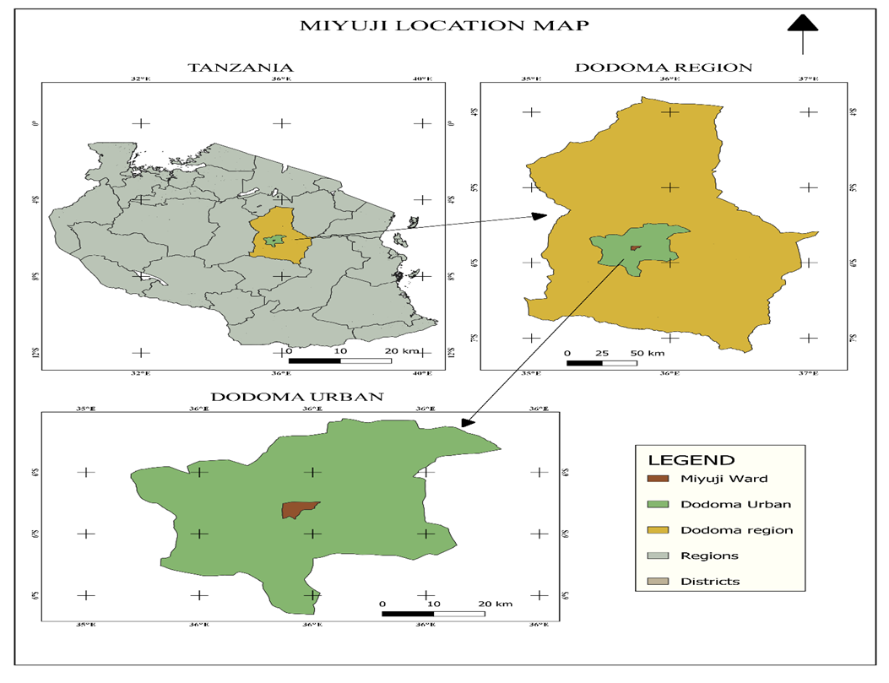
Figure 2: Map of Miyuji ward

3.2 Research Design
The research employed a non-probability sampling research design. This design allowed the researcher to involve the respondents once during the study. This design was appropriate because it allows the researcher to describe and analyze the implications of the daladala cut off trips on passengers travelling experience at Machinga Complex and St. Gemma. The study involved collecting data from the passengers who travel from Machinga Complex to St Gemma stations. The data analyzed using descriptive statistics, such as mean and standard deviation, to provide a detailed understanding of the implications of the daladala cut off trips on passengers.

3.3 Data Types and Sources

3.3.1 Primary Data
The primary data were collected through surveys, focus group discussions, and in-depth interviews. The survey questionnaire administered to 70 passengers. The questionnaire designed to collect information on the demographic characteristics of the passengers including age, marital status, and education. The focus group discussions and in-depth interviews conducted were with a purposive sample of 10 daladala drivers whose driving routes were from Machinga Complex to St. Gemma. These discussions aimed to provide in-depth information on the experiences and perspectives of the daladala cut off trips on passengers.

3.3.2 Secondary Data
The secondary data were collected from relevant literature, reports, and documents. The literature review included peer-reviewed articles, books, and reports related to daladala cut off trips on passengers in the African urban context. The documents to be reviewed included reports from the government, non-governmental organizations, and other stakeholders working on issues related to transportation in Tanzania. The secondary data used to provide a contextual understanding of the implications of cut off trips and inform the development of research questions and hypotheses (Table 1).
Table 1: Data collection matrix table
Specific objective | Data | Source | Data collection method | Data collection Tools | Data collection techniques
Specific objectives | Primary data | Respondents  -daladala operator  passengers | Interviews  observation | Questionnaires  checklist | Asking questions  Recording responses
 | Secondary data | Key informants  Transportation Authority | Document review | checklist | Perusing documents

3.4 Data Collection Methods and Tools
The primary data collection methods to be used in this study include structured interviews and questionnaires. The questionnaires were designed to collect data on the implication of the daladala cut off trips on passengers. The interview conducted using an interview guide that developed based on the research questions. The data collected from the interviews and questionnaires were analyzed using statistical software such as SPSS.

3.5 Sampling

3.5.1 Sampling Frame
The sampling frame for this study included all passengers in Dodoma city.

3.5.2 Sampling Unit
The sampling unit for this study were daladala passengers who travel through routes from Machinga Complex to St. Gema the passengers selected as the sampling unit since they were the primary focus of the study, and their experiences and perspectives essential in understanding the implications of the daladala route changes from Machinga Complex to St Gemma stations.

3.5.3 Sampling Size
The sample size of passengers was 70 be determined using a simple random sampling technique, which ensures that every passenger has an equal chance of being selected for the study. The sample size of 70 passengers and 10 daladala operators appropriate since it provides a representative sample of the passengers, ensuring that the study's findings were generalizable to the population of all passengers from Machinga Complex to St Gemma.

3.5.4 Sampling Procedures
The sampling strategy for the study were probability sampling. Non-probability sampling is appropriate for this study because the aim was to investigate the implications of daladala cut off trips from Machinga Complex to St Gemma to the passengers. Therefore, the study targeted all passengers who were willing to participate in the study.

3.6 Data Processing, Analysis and Presentation

3.6.1 Data Processing
The data collected from the questionnaires checked for completeness, coded, and entered into a statistical package for social sciences (SPSS) for analysis. The data cleaned to eliminate any inconsistencies, errors, or missing values. The cleaned data then be transformed into suitable formats for analysis.

3.6.2 Data Analysis
The data analyzed using descriptive and inferential statistical techniques. Descriptive statistics such as frequencies, percentages, means, and standard deviations were used to summarize the data. Inferential statistics such as correlation analysis and regression analysis used to test the hypotheses. The statistical significance of the results be tested at a 5% level of significance.

3.6.3 Data Presentation
The findings of the study presented using tables, charts, and graphs. The results presented clearly and concisely to facilitate easy understanding. The results presented according to the research questions and objectives. The researcher used qualitative and quantitative data to support the findings. The researcher also presents the results of the study in the context of the relevant literature reviewed in chapter two of the research proposal.

CHAPTER FOUR

RESULTS AND DISCUSSION

4.1 Introduction
This chapter presents the findings and discussion of the research result on implication of daladala cut off trips on passengers travelling experience from Machinga Complex to St Gemma route. This chapter is organized in four main sections. The first section is describing the demographic characteristics of the respondent, second section describes the route pattern from Machinga Complex to St Gemma, and third section described factors behind daladala cut off trips and fourth section describe challenges facing passengers as a result of daladala cut off trips.

4.2 Characteristics of respondents
Table 2: Characteristics of the respondent in Miyuji ward (N=100)
 | Category | Frequency | Percent
 | Male | 20 | 28.6
Sex | Female | 50 | 71.4
 | Total | 70 | 100.0
 | 18-24 | 37 | 52.9
Age | 25-34 | 22 | 31.4
 | 35-44 | 8 | 11.4
 | 45-54 | 1 | 1.4
 | 55 and above | 2 | 2.9
 | Total | 70 | 100.0
 | Single | 54 | 77.1
Marital | Married | 14 | 20.0
 | separated | 2 | 2.9
 | Total | 70 | 100.0
 | primary education | 4 | 5.7
 | secondary education | 9 | 12.9
Education | Undergraduate | 57 | 81.4
 | self employed | 15 | 21.4
 | employed | 5 | 7.1
Occupation | Student | 44 | 62.9
 | unemployed | 6 | 8.6
Source: Field Data, (2024)

4.2.1 Gender distribution
The data reveals a higher proportion of female participation (71.4). And male (28.6). The study show much affected gender is female (71.4) affected by the challenge of daladala route diversion (Table 2). Compared to male. Women who are rely on daladala for commuting to work or education institutions, this route diversion can create barriers to accessing opportunities. This can have negative consequences for their economic empowerment and educational attainment. (UN 2017)

4.2.2 Age distribution
Age of the respondents plays an important aspect in social analysis due to the fact that different age groups perform different sets of activities almost in all societies. That explain age can be seen as function of knowledge and experience as well as function the measure of maturity of an individual. The results show that the majority of respondents (52.9%) were age category (18-24), followed by the age between (25-34) years (31.4%). The other category (35-44) years (11.4%), and the other category (45-54) years (1.4%) and the last above 55 years (Table 2).

4.2.3 Marital status
The result shows that most of them are single (77.1%) others are married and separated. This implies that the most of the respondents interviewed in the study area are youth who had fewer financial resources available to cope with increased travel cost or time constraints and reduce access to employment and education (Table 2). So, this shows the importance of considering marital status when examining the impact of transportation changes (Akarcay and Clifton, 2019)

4.2.4 Education level
Result of education level of the respondents showed that (5.7%) primary education, (12.9%) secondary education and (81.4%) undergraduate level (Table 2). This show people of undergraduate have access to wide range of employment opportunities. Education may be relevant factors influencing the relevant of daladala cut off trips on passengers travelling experience (Baker, 2016)

4.2.5 Occupation
The result of research show most affected were students (62.9%) that impact on academic performance route changes affect student ability to attend classes and other academic activities on time. For self-employed (21.4%) this impact on business operations self-employed individuals’ ability to travel to meet clients, attend business meetings or transportation of goods and services impact on business and income (Table 2). For employed result show (7.1%) impact on work affect employed ability to arrive at work on time impact their productivity and job security and also increase travel cost which impact their household budget. And for unemployed result show (8.6%) which affect them to access with job interviews and other employment opportunities potentially hinder their job search efforts.

4.2.6 Frequency travel of respondents
The result show frequently passengers (64.3) moderate impact on travel time and cost. Frequent passengers may experience a moderate impact on their travel time and cost due to route changes, potentially affecting their daily routines and financial resource, so they were aware with of route changes and alternative transportation options and very frequent travelers (7.1%) had greater awareness of route changes and alternatives transportation. Also, not frequent (28.6%) shows lower awareness of route changes and alternatives transportation options and also had less reliant on public transportation (Table 3).
Table 3: Frequency travel of respondents
 |  | Frequency | Percent
 | Very frequently | 5 | 7.1
 | Frequently | 45 | 64.3
 | Not frequently | 20 | 28.6
 | Total | 70 | 100.0
Source: Field data (2024)

4.2.7 Primary mode of transportation
The result show most of passengers depend on public transportation (87.1%) experience a significant impact on their travel time and cost due to route changes, affecting their daily routine, productivity and financial resources and also rely on alternative modes of transportation such as walking, cycling and private transportation (12.9%) people who use private transportation as their primary mode of transportation may experience a limited impact on their travel time and cost due to route changes and they are not reliant on public transportation (UN Women, 2017) (Table 4).

Table 4: Primary mode of transportation
 |  | Frequency | Percent
 | Private Transport | 9 | 12.9
 | Public transport | 61 | 87.1
 | Total | 70 | 100.0
Source: Field work (2024)

4.2 Route pattern from Machinga Complex to St Gemma

4.2.1 Trip generation
The Fig.3 showed that many daladala operators the main boarding point along the Machinga Complex to St Gemma route was Machinga Complex; this location serves the most frequent alight point for passengers on route. The high volume of passengers boarding at Machinga Complex were likely due to several key destinations including recreational area, markets, shopping centers and health care facilities. And this location attributed to its role as a major transportation hub within Dodoma providing connections to various destination.

4.2.2 Trip distribution
Fig.3 implied the different stations or stops that daladala passes through on the route of Machinga Complex to St Gemma are Machinga Complex, Chinangali Park, Miti mirefu Njiapanda ya area C, Wajenzi, Darajani, Usomalini, Mchumia, Mti Mkavu, C.C.M, Mnadani, K.K.K.T, Mwisho wa rami, Upendo, Bible, Mipango, Madini, Miyuji filling station Kibaoni and St Gemma

4.2.3 Route Assignment
The report shown the criteria’s used by Transportation Authority (LATRA) in route assignment from Machinga Complex to St Gemma route were, demand assessment, by evaluating the passengers demand, also Geographical coverage by ensuring accessibility, route planning strategically designing routes to connect important destination such as schools, hospitals, and commercial centers. Integration with other transportation modes, also safety standards by ensuring that vehicles meet safety regulation by considering vehicle standards and drivers qualifications. The actions taken by Transportation Authority when got information about daladala cut off trips were investigation by investigate the reasons also Compliance checks, they checked if the operators were complying with regulations and service agreement, also the action taken by Transportation Authority was regulatory Actions they can impose penalties or sanctions on operators who fail to meet service obligations.
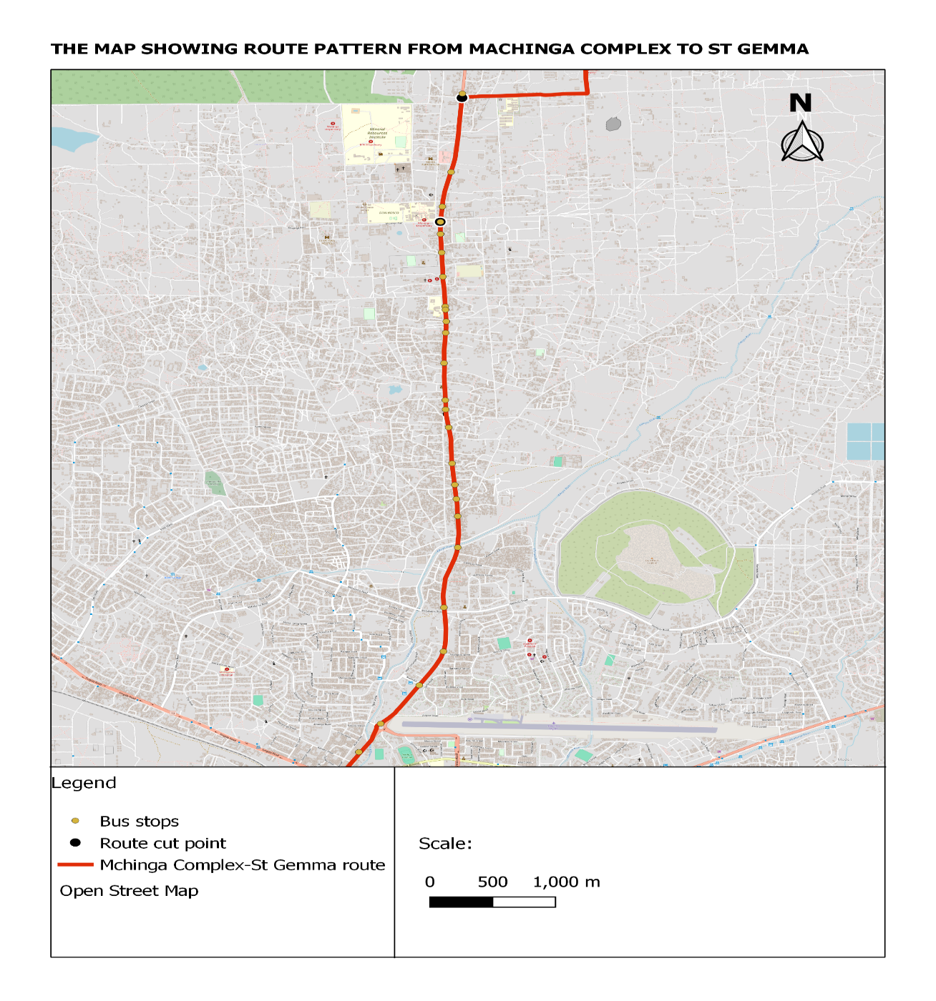
Figure 3: Route pattern from Machinga Complex to St Gemma
Source: Researcher illustration (2024)

4.3 Factors behind Machinga Complex to St Gemma

4.3.1 Economic factors for daladala cut off trips
Passengers demand were factors were main factors for daladala cut off trips(Table 5)show (37.0% )most of daladala operators cut trips due to passengers’ demand, daladala operators experience a significant drop in passenger demand, they chose to end their trips early to avoid operating empty vehicles, Also to save fuel to avoid prices the result show(29.6%) drivers choose to terminate their routes early to serve fuel, especially during periods of high fuel prices, another were seasonal factors especially holidays the result showed ( 25.9%) drivers cutting trips. Holidays, drivers choose to cut off trips early because much depend students and people who came from hospital, and other reason is competition the results show (7.4%) competition influence trip cutting, drivers feel that there are too many daladala on their route they choose to end their trip early and avoid further competition (Gonzalez and Rojas,2018).
Table 5: Economic factors for daladala cut off trips N (10)
 | Responses
 | N | Percent of Cases
Save fuel | 8 | 80.0
Competition | 2 | 20.0
seasonal factors especially holidays | 7 | 70.0
passengers demand | 10 | 100.0
Source: Field work (2024)

4.3.2 Social factors for daladala cut off trips
Passengers fear to advocate for their interests,(Table 6)show (27.8%) many passengers fear to advocate their interest, passengers hesitate to express their concern about daladala service due to low confidence, Also passengers paying fares below the set Amount by relevant Authority, the result show (13.9%) this is important issue of fare evasion or underpayment which can negative impact daladala operators, led them cutting trips and not reach at St Gemma, also safety concern, most daladala operators cut off trips during night for their safety issues led them to cut off trips. Passengers’ availability, daladala cut off trips they ended at Mipango main Campus and Kibaoni and not reach at destination St Gemma due to low population at St Gemma that’s let them cut trips (Martens, 2017).
Table 6: Social factors for daladala cut off trips
 | Responses
 | N | Percent of Cases
passengers fear to advocate their interests | 10 | 100.0
Passengers are paying fares below the set amount by the relevant authority | 5 | 50.0
safety concern | 10 | 100.0
passengers’ availability | 10 | 100.0
driver fatigue | 1 | 10.0
Total | 36 | 360.0
Source: Fieldwork (2024)

4.3.3 Environmental factors
Distance (Table 7) show (50%) daladala operators complain the distance were the reason for them cutting off trips that’s many passengers pay below fare so due to that reason they cut trips and many daladala operators had practice or notion of dropping off passengers due to before construction of road from Kibaoni to Swaswa (Plate 1) (Shafique and Muneer, 2016).
Table 7: Environmental factors for daladala cut off trips
 | Responses
 | N | Percent of Cases
Distance | 8 | 88.9
Drivers practice of dropping off passengers | 8 | 88.9
Source: Fieldwork (2024)
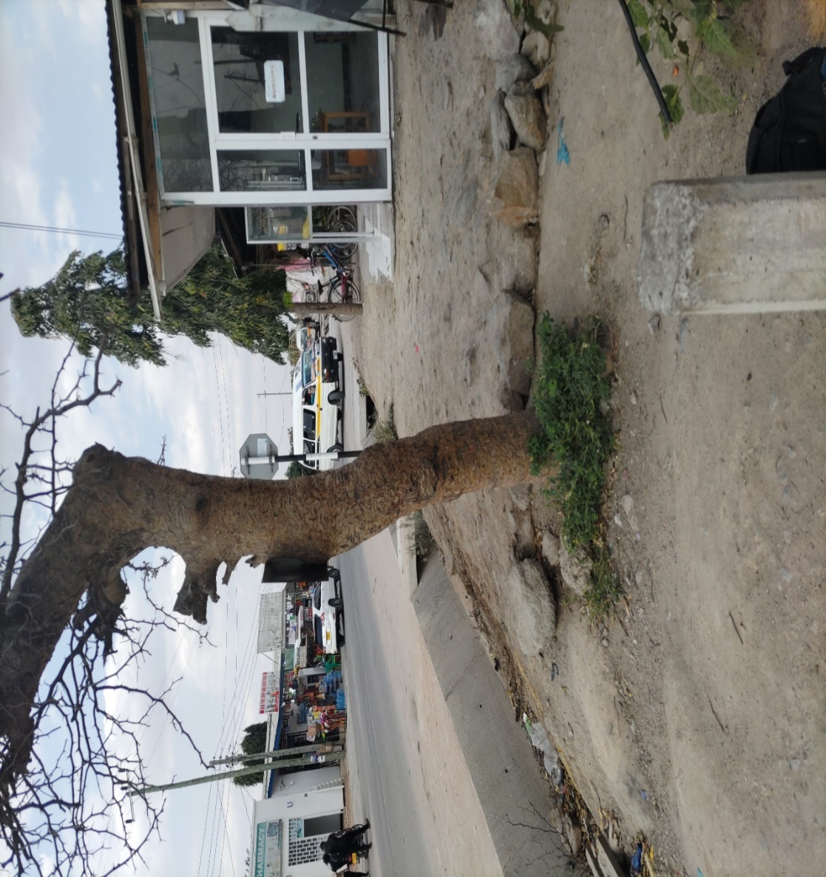
Plate 1: Daladala cut off trips at Kibaoni
4.4 Challenges facing passengers as a result of daladala cut off trips
4.4.1 Social challenges facing passengers
Time consuming the result showed (25.5%), when daladala cut trip led time consuming to find alternative transport to reach destination, this much impact students to late at schools or colleges, increase of travel time the result showed (24.3%) because other had no additional cost for alternative transportation and decided to walk, another challenge was in access to basic services like hospital, education. led disruption of daily activities Safety challenges, robbery and crime; (Table 8) showed (3.5%) passengers who live at St Gemma faced with that problem during night, also challenge faced passengers that daladala operators does not inform passengers early that they cut off trips. So, this makes passengers dilemma (Carter and Jansen 2018).
Table 8: Social Challenges faced passengers
 | Responses
 | N | Percent of Cases
Safety challenge; robbery and crime | 9 | 12.9
disruption of daily activities | 59 | 84.3
Time consuming | 65 | 92.9
Increase of travel time | 62 | 88.6
In access to basic services | 60 | 85.7
Source: Fieldwork (2024)
4.4.2 Economic challenges facing passengers
Increasing of transportation cost this were main challenge faced passengers’ additional cost (Table 9) show (25.9%) affected by that that they used additional cost to take alternative transportation like motorcycle the price of 2000 from Kibaoni to St Gemma compare to daladala from town were 700 shillings. Another challenge was increase in inequality (25.5%) this were due to different income of an individual some can afford the cost of alternative that’s other walk from kibaoni to St Gemma and other afford to took alternatives, another missing some opportunities (24.3%) due to daladala cut off trips led some people miss some opportunities that passengers did not reach at specific area at the time cause to lose an opportunity and other led to impact on local business that due to lose of customers led decrease of income (Bohte and Maat 2017).
Table 9: Economic challenges faced passengers
 | Responses
 | N | Percent of Cases
increase of transportation cost | 65 | 94.2
Missing some opportunities | 61 | 88.4
loss of income | 4 | 5.8
Impact on local business | 57 | 82.6
Increase inequality | 64 | 92.8
Source: Fieldwork (2024)
4.4.3 Psychological challenges faced passengers
According to the report much affected were women that complain increase stress were daladala operators used abused language for passengers (Table 10) showed (78.3%) most of them women when they advocated their interest and another challenge was increase of fear during night (21.7%) passengers fear to walk from Kibaoni to St Gemma to scare robbery and crimes and also fear this alternative during night many are not really alternatives operators’ others were thieves and killers this especially daladala cut off trips during night (Haq and Beecham, 2017).

Table 10: Psychological Challenges faced passengers
 | Responses
 | N | Percent of Cases
Increase of stress | 54 | 100.0
Increase of fear | 15 | 27.8
Source: Fieldwork (2024)

CHAPTER FIVE

CONCLUSION AND RECOMMENDATIONS

5.1 Conclusion
Route pattern; Due to many passengers use daladala as their primary mode of transportation and many passengers travel frequently by using public transport ‘daladala’ from Machinga Complex to St Gemma route Transportation Authority and other related Authority should improve the area of St Gemma Station that support passengers to wait vehicles and daladala operators to wait passengers.
Factors behind daladala cutting off trips: Due to various factors led daladala operators to cut trips transportation Authority should assist daladala operators to provide them fuel because many daladala operators not reach at St Gemma was low number of passengers in St Gemma so many of them fear consuming fuel that sometimes not follow passengers from St Gemma and came with empty daladala from St Gemma so this led them to cut off trips and end up at Kibaoni and Mipango main Campus. Also, Passengers should pay fare which arranged by relevant Authority LATRA.
Challenges facing passengers
Passengers experience a challenge due to daladala cut off trips, impacting their social, economic and psychological well-being. Addressing these challenges enhancing service reality, daladala operators should improve their communication with passengers and investing in infrastructure.
The actions taken by Transportation Authority when got information about daladala cut off trips first were investigate by investigate the reasons also Compliance checks, they checked if the operators were complying with regulations and service agreement, also the action taken by Transportation Authority was regulatory Actions they can impose penalties or sanctions on operators who fail to meet service obligations.

5.2 Recommendations
- Traffic officers should stand for the area affected by cut off trips especially Mipango and Kibaoni by forcing them to reach destination at St Gemma to meet the need passengers.
- Land Transportation Regulatory Authority should provide education for passengers through mass medias and platforms that will make sure hear the passengers complains. This will ensure their voices are heard and their needs are considered in policy making process.
- Government agencies, transportation Authority, civil society’s organizations and daladala operators should collaborate together to develop and implement solutions about daladala cut off trips.

REFERENCES
ABC. (2018). East Africa transport and connectivity report. Retrieved from https://www.eabc-online.com/wp-content/uploads/2018/09/east-africa-transport-and-connectivity-report-2018.pdf
Afdb. (2019). Africa's urbanization dynamics 2018: Africa polis, Mapping a New Urban Geography.
Agnant, D. J., and Kockelman, K. (2015). Preparing a nation for autonomous vehicles: opportunities, barriers and policy recommendations. Transportation research part a: Policy and Practice, 77, 167-181.
Bellemans, T., Janssen, D., and Wets, G. (2016). Minibus route choice behavior in a developing country: the case of Kigali, Rwanda. Transportation research part a: Policy and Practice, 93, 57-68.
Bellemans, T., Janssen, D., and Wets, G. (2016). The relative impact of service quality dimensions on overall service quality and customer satisfaction. Transportation research part a: Policy and Practice, 94, 374-385.
Bohte, W., and Maat, K. (2017). "The Effect of Transport Costs on Public Transport Demand." Transport Research Part A, 95, 33-42.
Chaiwong, J., Wibulpolprasert, S., and Bhidayasiri, R. (2020). Influential factors affecting travelers' mode choice behavior on mass transit systems. Sustainability, 12(11), 4541. https://doi.org/10.3390/su12114541
Chakrabarty, A., and Roy, D. (2018). Study on safety aspects of a metro rail system. Journal of Transportation Safety and Security, 10(3), 233-246.
Chen, Y., Jiang, R., and Xu, X. (2018). Modeling passenger satisfaction in multimodal public transportation: evidence from Shanghai. Transportation research part a: Policy and Practice, 112, 1-11.
Data. (2021). Report on daladala Cut off trips from Machinga Complex to St Gemma route in Dodoma city. Unpublished Manuscript.
Gonzalez, R., and Rojas, C. (2018). "Fuel Price Elasticity in Public Transport." Journal of Transport Economics and Policy, 52(2), 233-250.
Goodwin., and Van Dijk, T. (2020). Changes in mode share of passenger travel in the Uk: A review of official statistics. Transportation Planning and Technology, 43(5), 478-489.
Hart, J. (2012). Role of public transportation in providing good accessibility. Journal of Public Transportation, 15(4), 1-17. https://doi.org/10.5038/2375-0901.15.4.1
He, F., Zhang, Y., and Yang, J. (2022). Challenges and opportunities for electric buses in China's public transit system. Sustainable Cities and Society, 76, 103607.
Huang, Y., Chen, Y., and Chao, C. (2020). Embracing the smart city paradigm: exploring factors influencing passengers' intention to use smart public transportation services. Sustainability, 12(13), 5433.
Huang, Y., Chen, Y., and Chao, M. (2020). Evaluating the impacts of transit service quality on passenger satisfaction and loyalty: a case study of metro line 1 in Wuhan, china. Journal of Transport Geography, 82, 102610.
Isyagi, N. (2013). The role of Dala Dala public transport in providing accessibility to the urban poor in Tanzania: a case study of Dar es Salaam. University of Dar es Salaam Library Journal, 10(1), 118-127.
Kamaruddin, S., Ali, A., and Jusoh, R. (2014). Factors influencing passenger satisfaction on public transportation. Procedia-Social and Behavioral Sciences, 153, 19-27. https://doi.org/10.1016/j.sbspro.2014.10.014
Kiinsi, R. (2019). A review of traffic congestion in dar es Salaam city from the physical planning perspectives. Habitat International, 53, 353-359.
Kimario, S. G. (2022). Assessment of Commuter Satisfaction towards Public Transportation Transition from Hiace Buses to Daladala Buses in Mbeya City, Tanzania. International Journal of Scientific and Technology Research, 11(3), 120-130.
Kundi, G. M. (2014). Factors influencing customer satisfaction in urban public transport. Journal of Transport and Logistics, 1(1), 1-9. https://doi.org/10.11648/j.jtl.20140201.11
Lwenje, D. R. (2020). The role of small-scale passenger transport services in African cities: The case of dalla-dallas in Dar es Salaam, Tanzania. Transportation Research Procedia, 48, 609-618.
Ma, J., Hou, Y., and Zheng, L. (2022). Electric Bicycles, Public Transport, and Transportation Sustainability in Chinese Cities. Sustainability, 14(3), 1302.
Mike, I. (2015). The phenomenal increase in demand for intercity passenger transport in Nigeria. Journal of Transport Economics and Policy, 49(3), 443-454.
Molin, E., andKoglin, T. (2019). A comprehensive approach to measuring public transport service quality. Transportation Research Part a: Policy and Practice, 127, 42-57.
Mwakalonge, J. L., Fillela, I., and Bauk, S. (2011). Cost-recovery analysis of parallel Dala Dala operations in Dar es Salaam, Tanzania. Research in Transportation Economics, 36(1), 37-45.
NBS. (2016). Transport Sector Statistics Report 2016. Retrieved from https://www.nbs.go.tz/nbs/takwimu/references/transport_report_2016.pd
Nkurunziza, H. (2018). Commuters' attitudes towards the proposed bus rapid transit system in Dar es Salaam. Transportation Research Part A: Policy and Practice, 118, 78-92. https://doi.org/10.1016/j.tra.2018.08.027.
Saito, M., and Fujii, S. (2017). Passengers’ satisfaction with public transportation: an analysis of the effects of service quality, expectations, and personal characteristics. Transportation Research Part a: Policy and Practice, 101, 192-202.
Saito, M., and Fujii, S. (2017). Public transportation satisfaction and its determinants in Japan: An Analysis of Passenger Survey Data. Transport Policy, 55, 1-8.
Talebian, K., Karimi, A., and Chauhan, S. (2022). Sustainable urban transportation technology adoption under uncertainty: A state-of-the-art review. Transport Reviews.
UITP. (2020). Public transport trends 2020. https://www.uitp.org/publications/public-transport-trends-2020/.
URT (United Republic of Tanzania). (2021). National Urban Transport Policy. Ministry of Works, Transport and Communications.
Weng, M., and Fan, Y. (2019). An empirical analysis of factors affecting passenger satisfaction and loyalty in urban rail transit: evidence from Guangzhou, china. Sustainability, 11(6), 1572.
Chibanda, T. (2023). Economic Viability in Informal Transport Systems. Dodoma University Press.
Chilumba, R. (2023). Passenger Experiences in Urban Transport. Journal of Urban Mobility, 15(2), 45-60.
Kibanda, J. (2023). Delays in Public Transport: Causes and Effects. Transport Review, 12(1), 34-50.
Kibona, M. (2022). Mental Health Implications of Commuting Stress. Health and Society Journal, 24(4), 78-92.
Mwanga, P. (2022). Route Patterns and Passenger Satisfaction in Dodoma. Journal of Transport Geography, 30(3), 112-126.
Mwanza, F. (2021). Urban Commuting in Tanzania: Challenges and Opportunities. African Transport Research Journal, 18(1), 22-36.
Ng’umbi, E. (2022). Regulatory Challenges in Informal Transport. Transport Policy Journal, 19(2), 66-80.
Moshi, A. (2023). Safety in Urban Transport: A Case Study of Dodoma. Journal of Safety Research, 15(5), 89-102.
Suleiman, H. (2022). Economic Pressures in Informal Transport Systems. East African Journal of Economics, 16(3), 101-115.
Cervero, R. (2017). Paratransit in developing countries: A framework for analysis and policy-making. Transport Policy., 24(4), 78-92
Haq, G., and Beecham, R. (2017). "The Psychological Impact of Public Transport Experiences." Transport Reviews, 37(2), 203-218.
Litman, T. (2021). Evaluating transportation demand management strategies. Victoria Transport Policy Institute. 55, 1-8.

APPENDICES
Appendix 1 : Questionnaire for Respondents
1. What is your gender?
a. Male b. Female c. Other
2. What is your age?
a. 18-24 b. 25-34 c. 35-44 d. 45-54 e. Above 55
3. Marital status of the respondent
a) Single b) Married c) Widow d) separated [ ]
4. What is your occupation?
a. Student b. Employee c. Self-employed d. Unemployed e. Other [ ]
6.How frequently do you travel from Machinga Complex to St Gemma daladala?
Very frequently | Frequently | Neutral | Not Frequently | Not at all
7.What is your primary mode of transportation for travelling from Machinga Complex to St Gemma daladala
a) Public transport b) Public transport c) walking
8. Where do you start your daladala trips for this route between Machinga Complex to St Gemma? You begin your trips?
………………………………………………………………………………………
9. Can you tell me the names of different stations or stops that your daladala passes through on the way from Machinga Complex to St Gemma? Could you list out all the stations where you pick up and drop off passengers along this route?
……..………………………………………………………………………………………
10. What are the criteria’s that used to evaluate route assignment. And are there any feedback about daladala cut off trips and what are the actions taken for those who cut off trips?
…………… ………………………………………………………………………………
SECTION C: Factors behind Machinga Complex to St Gemma daladala cut off trips
11.There are any economic issues that contribute to the daladala cut off trips from Machinga Complex to St Gemma? If yes tick and how
- Save fuel
- Competition
- Seasonal factors especially holidays
- Passengers demand
13. There are any social factors for the Daladalacut off trips? If yes tick and how
- Passengers fear to advocate for their interests
- Passengers are paying fares below the set amount of relevant Authority
- Safety concern
- Passengers’ availability
14. Are there any technical factor that led for daladala cut of trips? If yes tick and how
- P road condition
- Vehicles mechanical issues
- Traffic congestions
15. There are any environmental factors contribute for the daladala cut off trips? If yes tick and how
- Distance
- Drivers had practice of drop out passengers out of destination
SECTION D: Challenges facing passengers as a result of daladala cut off trips
16. Have you ever experienced social challenges? If yes tick
- Safety challenge, crimes and robbery
- Disruption of daily activities
- Time consuming
- Increase of travel time
- In acess of basic services
17. Have you experience economic challenges as a result of daladala cut off trips? If yes tick
- Increase of transportation cost
- Missing some opportunities
- Loss of income
- Impact on local business
- Increase inequality
18. As passenger had you experience psychological challenges? If yes tick
- Increase of stress
- Increase of fear
Appendix 2: Questionnaires for key informants
1. What are the criteria used to determine the number of vehicles from Machinga to St Gemma route?
……………………………………………………………………………………………
2. What are the actions taken for daladala operators who cut off trips?
……………………………………………………………………………………………

